SH-852 Epoxy Balance Mortar

product description ：
The SH-852 epoxy balancing mortar consists of two components, A and B, primarily composed of epoxy resin and curing agent, with fillers added as required. Component A is blue (red/black optional), while component B is grayish-white.

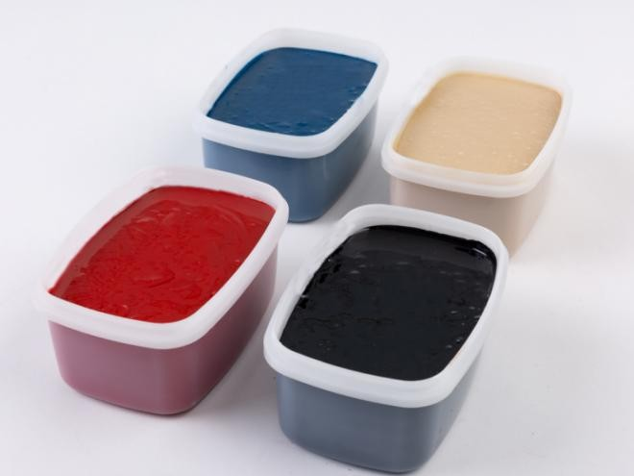
product features ：

Excellent formability and thixotropy

- strong adhesion

- Excellent insulation performance, heat resistance class F

- Halogen-free and environmentally friendly

Typical application:

- Dynamic Balance Calibration of Wound Rotor for Lifting Motors, Automobile Motors, DC Motors and Micro Motors

- MATERIALS FOR MOLDING AND BONDING OF MOTOR/RUNNING THERM ROLLER/ELECTRIC WELDER AND OTHER EQUIPMENT

main performance index ：

Function | Condition of expe- riment | Unit | Desired value
Surface | Visual inspection at room temperature | - | Plastic in consistency, blue (red/black optional) at room temperature for Group A, grayish-white for Group B
Period of use | After mixing the two components, at 20±5°C | h | ≤1
Firm time | After mixing the two components, at 20±5°C | h | ≤24
Density of hardened material | 20±5℃ | g/ml | 2.5±0.1
Hardening property | Ambient temper- ature | ℃ | 5~10 | 20 | 25 | 30 | 70
Hardening property | Firm time | h | 24~36 | 12~24 | 6~12 | 2~4 | 1~2
Shear strength | - | MPa | ≥8
Dynamic bond strength | At room temp- erature | m/min | 2000
Note: The above data are test values obtained by our company using recognized inspection methods. To ensure proper selection of our products, please review the data and try them out, or contact our engineers for further assistance.

usage method ：
- The surface of the workpiece to which the adhesive paste is applied should be clean and dry. If oil stains are present, they should be removed with alcohol.

- Before application, mix component A and component B in a volume ratio of 1:1 (weight ratio of 2.1:1.9), and knead by hand at room temperature until the color is uniform. The simplest method is to repeat the twisting and braiding process of " stretching-twisting-folding".
- Press the indicator of the dynamic balance to measure the imbalance, then remove the pre-mixed adhesive paste and apply it to the unbalanced area of the workpiece.

- Calibrated workpieces can harden spontaneously within 24 hours at room temperature not lower than 5°C. The clay exhibits no weight or shape changes during hardening, and the curing rate increases with rising temperature.
- If the room temperature is too low in winter, when the clay is hardened, it can be heated to softness using an electric stove or hairdryer, or placed in a low-temperature oven at 30°C for half an hour. The surface to be bonded may also be preheated appropriately.
- The adhesive is non-toxic and non-irritating. After use, hands should be wiped with 95% alcohol and then washed with soap.

Packaging and storage:
- Components A and B are separately packaged in covered polyethylene plastic boxes, with 2.1kg of component A per box and 1.9kg of component B per box, totaling 4kg per set. Components A and B are supplied as a matching set.

Components A and B are stored at room temperature, with a shelf life of 12 months from the date of manufacture.

Note: The above data represent test values obtained by our company using recognized inspection methods. To ensure proper selection of our products, please review the data and conduct a trial, or contact our engineering department.

The staff will be available to provide you with further assistance.

